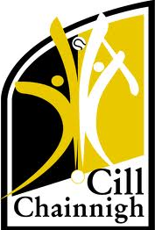
13th September, 2021
Press Release – Inter-county Hurling Managers 2022
Following a meeting of the Kilkenny GAA County Board on Monday night, Brian Cody has been ratified as Kilkenny Senior Manager for the 2022 season. James McGarry, Martin Comerford and Conor Phelan will be selectors for the season ahead.
At U-20 Derek Lyng has been ratified as manager for the season ahead, with Peter Barry, Michael Rice and Peter Donovan on board as selectors.
At U-17 Niall Bergin has been ratified as manager. A management team to assist Niall will confirmed at a later date.
Kilkenny GAA would like to take this opportunity to wish all our management teams and panels the best of luck in the season ahead.

ENDS
For more information
Paul Fitzgerald – pro.kilkenny@gaa.ie

